Dow Jones Industrial (DJI) Index Prediction

Traders Assignment 1

On this paper, daily view of chart is going to be used as it is more accurate in predicting the current swing trend in the market. Candle chart is preferred over other types of chart as it provides more data if compared to line and it is visually more pleasing comparing to bar chart. Here will be discussed about the prediction of the movement of DJI Index, which is an index of 30 large, publicly owned company on the New York Stock Exchange and the NASDAQ.

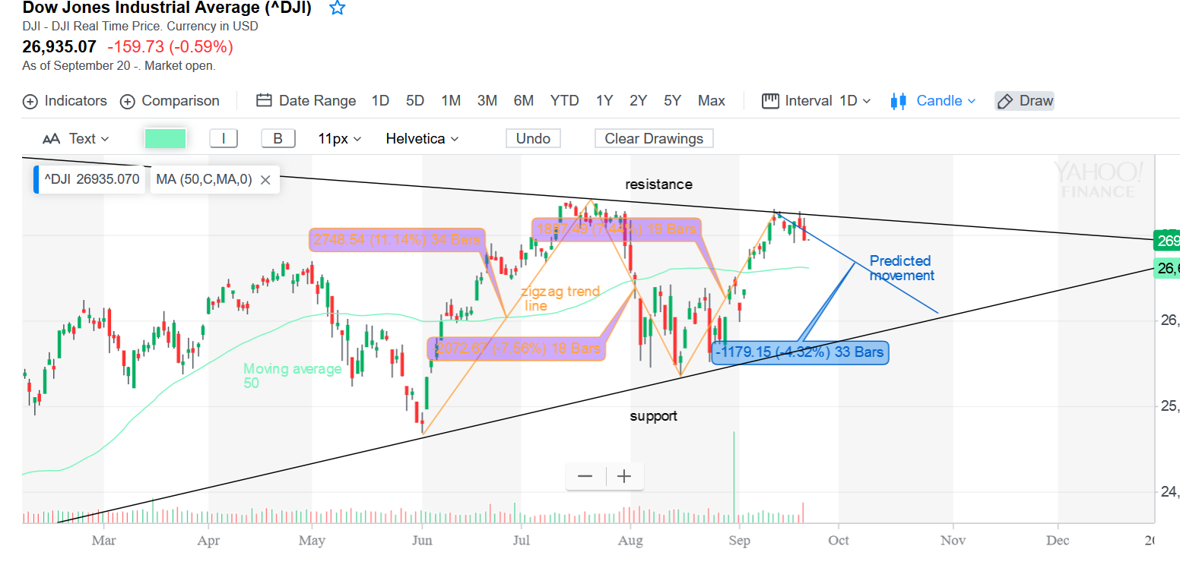The analysis on DJI starts with an observation on the chart, which uses technical skills to predict its future movement. Based on the chart below, first by looking at the Moving Average 50 trend line, the trend is upward, or bullish. There exist a resistance and support, creating a pattern which resembles a pennant or flags, which looks like a narrowing zigzag pattern inside resistance and support, waiting until a consolidation (breaking the resistance or breaking the support) that determines the future movement of the pattern. The presence of a gravestone doji on the last edge of the zigzag creates a strong reversal to create another zigzag pattern.

This zigzag pattern can also be interpreted as a moment when the trade market is unsure about the worth of the stocks in the index. This could happen due to the trade war which currently exist between America and China, where there hasn’t been any definite action that is made by both. The market, or the traders, are waiting for definite news, which could create a breakthrough either on the resistance or the support, up to which opposition is favored.